Chap 0 Introduction

0.1 The Role Of Algorithms

* **Algorithm**: A set of steps that defines how a task is performed
* **Program**: A representation of an algorithm
* **Programming**: The process of developing a program
* **Hardware**: The machinery
* **Gödel's Incompleteness Theorem**: Some problems cannot be solved by algorithms.

0.2 The History of Computing

End of 20th century

* Internet revolutionized communications

- World Wide Web

- Search Engines

* Miniaturization of computing machines

- Embedded (GPS, in automobile engines)

- Smartphones

0.4 The Overarching Themes of CS

Abstraction

* **Abstraction**: The distinction between the external properties of an entity and the details of the entity’s internal composition.
* **Abstract tool**: A “component” that can be used without concern for the component’s internal properties.

Programming

* is broadly referred to as:

- Translating human intentions into executable algorithms

* Abstraction in a **programming language** allow humans to reason and encode solutions to complex problems

Chap 1: Data Storage

* 1. Bits and Their Storage
* **Bit**: Binary Digit (0 or 1)

**Boolean Operation**: An operation that manipulates one or more true/false values

**Gate**: A device that computes a Boolean operation

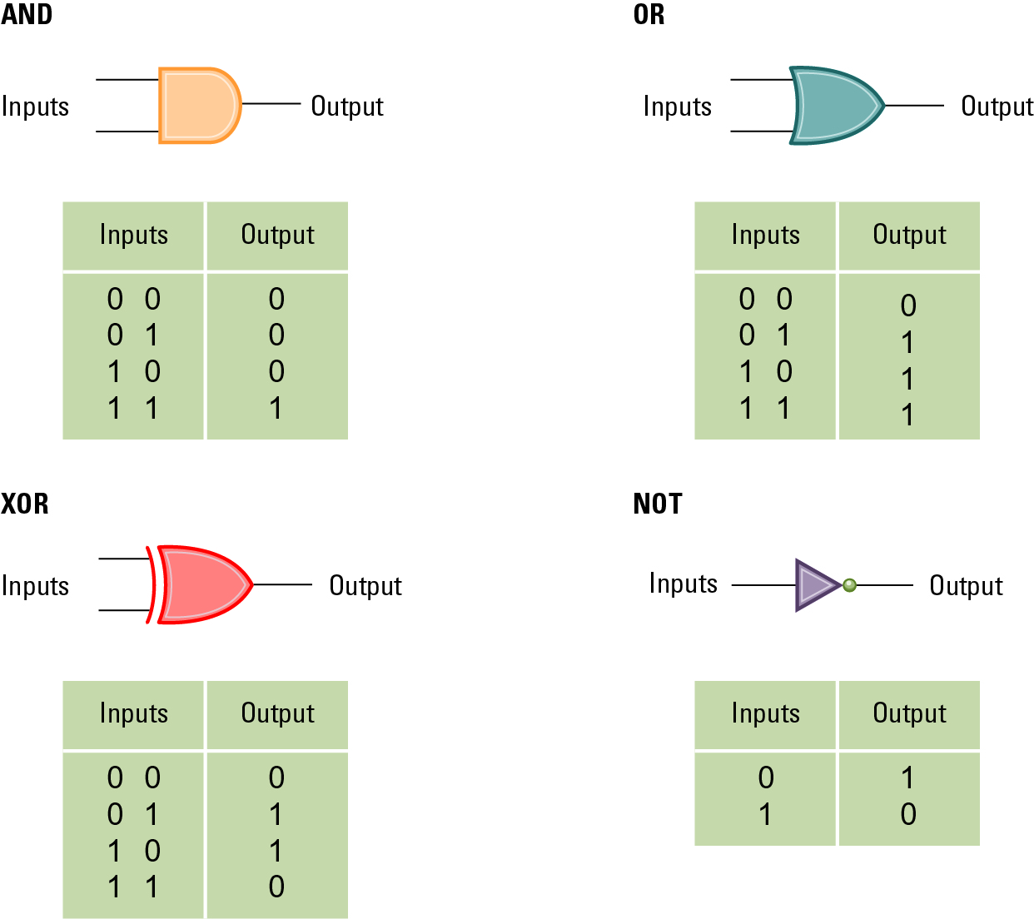

**Flip-flop**: Circuits built from gates that act as a fundamental unit of computer memory

**Hexadecimal Notation**: A shorthand notation for long bit patterns

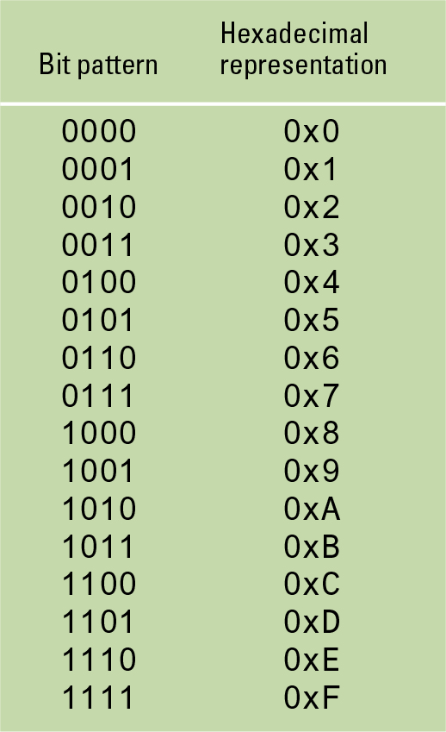Ex. 10110101 becomes 0*B5

* 1. Main Memory
* **Cell**: A unit of main memory (typically 8 bits which is one **byte**)

- **Most significant bit**: the bit at the left (**high-order**) end

- **Least significant bit**: the bit at the right (**low-order**) end

* **Address**: A “name” that uniquely identifies one cell in the computer’s main memory
* **Random Access Memory (RAM)**: Memory in which individual cells can be easily accessed in any order
* **Dynamic Memory (DRAM)**: RAM composed of volatile memory

Measuring Memory Capacity

* **Kilobyte**: 2^10 bytes = 1024 bytes Ex. 3 KB = 3*1024 bytes
* **Megabyte**: 2^20 bytes = 1,048,576 bytes Ex. 3 MB = 3*1,048,576 bytes
* **Gigabyte**: 2^30 bytes = 1,073,741,824 bytes Ex. 3 GB = 3*1,073,741,824 bytes
  1. Mass Storage

**Bandwidth**: The total amount of bits that can be transferred in a unit of time

**Latency**: The total time between the request for data transfer and its arrival

**Flash Memory**: circuits that traps electrons in tiny silicon dioxide chambers

**SD Cards** provide GBs of storage

* 1. Representing Information as Bit Patterns

Representing Text

* **Each character (letter, punctuation, etc.) is assigned a unique bit pattern**

- **ASCII**: Uses patterns of 7-bits to represent most symbols used in written English text

- **ISO** developed a number of 8 bit extensions to ASCII, each designed to accommodate a major language group

- **Unicode**: Uses patterns up to 21-bits to represent the symbols used in languages world wide, 16-bits for world’s commonly used languages

Representing Numeric Values

* **Binary notation**: Uses bits to represent a number in base two

Representing Images

* **Bit map** techniques

- **Pixel**: “picture element” represents one dot